Team: Data Junkies
Project: Employee Database Application
Project Deliverable: Week 3

Team Participation Report

Bill Wodon (Team Leader): 55%
Did most of the project requirements, and wrote descriptions of the entity classes

Tom Paracelcius: 45%
Was responsible for the user role diagram

Together
We met together to figure out the project details and did the ER diagram together.
We both reviewed and commented on each other's work on the project requirements and the user role diagram

Requirements

An Employee Database Application keeps track of all employees of a small company, including their name, job and salary. The company is divided into departments (with a name and location), and every employee works for a single department.

An employee can optionally provide and change their own address, and can see the address of any other employee who has provided an address and made it public, given that employee's name. An employee can see a list of the names and jobs of all the employees in their own department, and can find out the department and location of another employee given their name.

Every employee (except for the President – the employee whose job is 'PRESIDENT') has a manager, who directly manages them. An employee does not need to be in the same department as their direct manager. Managers can get a list of all the employees that they directly manage, or all employees beneath them in the management hierarchy, along with the job, salary and manager of each.

Every department has at most one department manager (the employee in a department whose job is 'DEPTMGR'), and must have a department manager if it has a clerk. Any employee can find out the managers of the various departments. Every department manager may also directly manage employees, and all department managers are directly managed by the president.

A department manager can see the job, salary and manager of all other employees in their department, and can change the jobs and salaries of all the other employees in their department, and terminate employees in their department. A department manager can hire a new employee for their department, and can change the direct manager of an employee in their department only if both the old and the new manager are in the same department.

A department without a manger has an acting manager (as long as the department has employees). When a department loses its manager or acting manager, the employee in the department with the highest salary (or one of them if there is more than one) becomes the acting dept manager.
The president can see and change the jobs, salaries, managers, and departments of all other employees, and can hire and terminate any other employee. The President can also create and destroy departments and move them to a new location. When destroying a department, the President can choose to either terminate all the employees in the department, or move them all together to a different department. However, no operation can affect the president.

Entity-Relationship Diagram

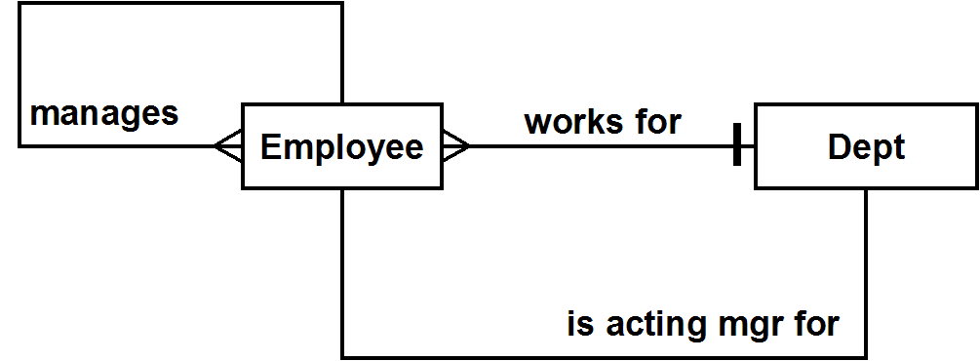

Entity Classes

Employee -- an employee of the company
Dept -- a department of the company
User Role Diagram

